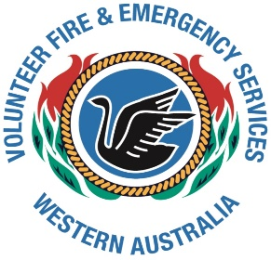
ESVA
YOUR SERVICE – YOUR VOICE
Welcome to your latest Association Update.
APRIL 2016
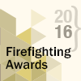
2016 FIRE & EMERGENCY SERVICE AWARDS.
Nominations for the Awards are now open. We urge Services to nominate. The Nomination forms are available on the DFES Website – click on News & Media on LH side of page scroll down to Awards. Nomination for the awards close on Wednesday 4th May.
This year the Outstanding Brigade/Unit has been incorporated into the Firefighting Awards.

FIREFIGHTER MEMORIAL SERVICE
This Service is on Sunday 1st May at the Firefighter Memorial Grove, Forrest Drive, Kings Park. If you are planning to attend please be there by 11.15am.
This Service is to remember firefighters from around the State that have lost their lives protecting the community. It would be great to see Volunteer Fire & Emergency service personnel there. The VFES will be represented in the Flag Party this year and we thank Warwick from Bullsbrook for doing this.

CONFERENCE
This year’s DFES Volunteers Conference is being held from Friday Sept 9th – Sunday 11th. Planning is well underway. Again the Association will be hosting a meal on the Saturday night, if you have any suggestion please let us know. We will also be holding our AGM throughout the weekend and encourage all delegates to attend this. It is your chance to have a say. Notice and call for Agenda items will be sent out in July.
This year both DFES and the Assoc are encouraging services to send a least one new delegate, we encourage this as it is a good learning experience for volunteers.

ASSOCIATION COMMITTEE
Due to personal issues we have lost a couple of members from the Committee this year and are looking for new members, it can be very challenging and frustrating, but is also very rewarding. If anyone out there is interested, please contact the Assoc.

VFES LIFE MEMBER BADGES:
These are now available to purchase from the Assoc. Please contact the Secretary.
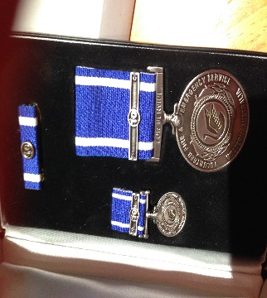
VFES SERVICE MEDALS
DFES now have a stock of the new 10 years onwards VFES medals.
These are ordered from DFES through your DFES A/O.
We will have samples of both medals on display at the Conference.

WEBSITE
Unfortunately our website is not to the standard we were after or promised so we are currently going through the process again of developing a new site. The new one will be more informative and interactive. Meantime the old site will still be up with relevant basic information on it.

WAROONA SUBMISSION
The Association submitted a submission in to the Waroona Fire Enquiry, this is on the Ferguson enquiry website. Thankyou to the volunteers who gave us feedback on the fire.

VFES RULES & REGULATIONS
These have now been signed off by DFES and have been posted on the Volunteer Portal under Doctrine. If you would like a copy emailed, please contact Association Secretary.

PATHWAYS
We are aware that some of the current Pathways are causing issues with our services. The Association is continuing talks with DFES to assist with rectifying the problems. We will be seeking assistance from our volunteers on this issue.

THANKYOU
A big thankyou to all FES volunteer who assisted at major incidents throughout the state this summer.
Thankyou to the volunteers that have put their hands up to attend different DFES Advisory groups meetings as representatives for the Association. This assists the Association by increasing the VFES representation and viewpoint at these meetings.

Reminder that the Association is here to assist you with any issue your Brigade may have, so please do not hesitate to contact a Committee Member for assistance.

